HEALTHCARE MANAGEMENT

PREPARED BY, SARAVANAPRIYA.D

INTRODUCTION:
The project titled Health care Management, is about the Patient demographics, Appointments, Doctors workload, Hospital utilization etc., The dataset is taken from (Mockaroo.com/datasets). Analyzing this dataset, we can understand the Total patient appointments, Hospital capacity, Doctors workload per patient, Insurance coverage and clinical insights which will be more helpful for better healthcare management.

OBJECTIVE:
The main objective of this project is to analyze the given dataset, perform data cleaning using SQL, perform Derived metrics using SQL, to import into Power BI Desktop for making interactive dashboard, derive suitable DAX formulae and to create meaningful clinical insights for better healthcare analysis.

DATASET DESCRIPTION:
The excel dataset consist of multiple sheets named Patients, Hospitals, Doctors, Appointments, Treatments and Billing.
Each sheets consist of a primary key and it also includes Patient demographics, Hospital appointments, Patient treatments and the billing process. The following are the brief of each sheets:
- Patients sheet includes patient demographics and registration details.
- Doctors sheet includes each and every individual doctors specialization and their experience.
- Hospitals sheet includes bed capacity, ICU capacity and their working staffs information.
- Appointment sheet includes patient’s appointment date, doctor ID, Patient ID and their status of treatment.
- Treatment sheet includes cost of all the lab test, medications and the treatment that the patient taken.
- Billing sheet includes total billing amount and insurance coverage information.

DATASET CLEANING:
The following are the steps used in data cleaning process.
- The tool used in data cleaning process is SQL.
- Analyzing the raw data.
- The messy dataset is up to 1000 rows.
- Removed duplicates using Distinct.
- Change and ensure each column in the sheet have consistent datatype.
- Handling missing values by replacing null or 0.
- Performed suitable metrics.
- Finally, the dataset is kept ready for importing into Power BI desktop.
- The Dashboard has been done in Power BI desktop.

MESSY DATASET:
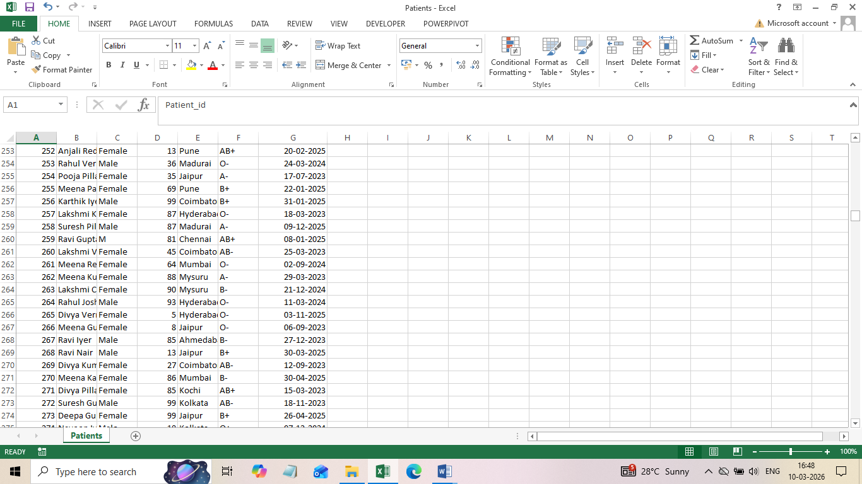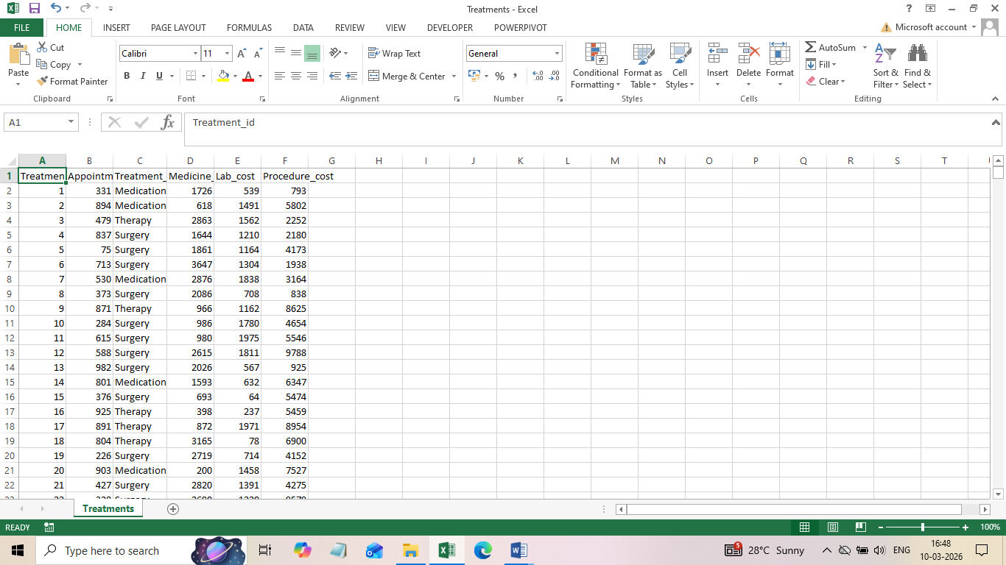
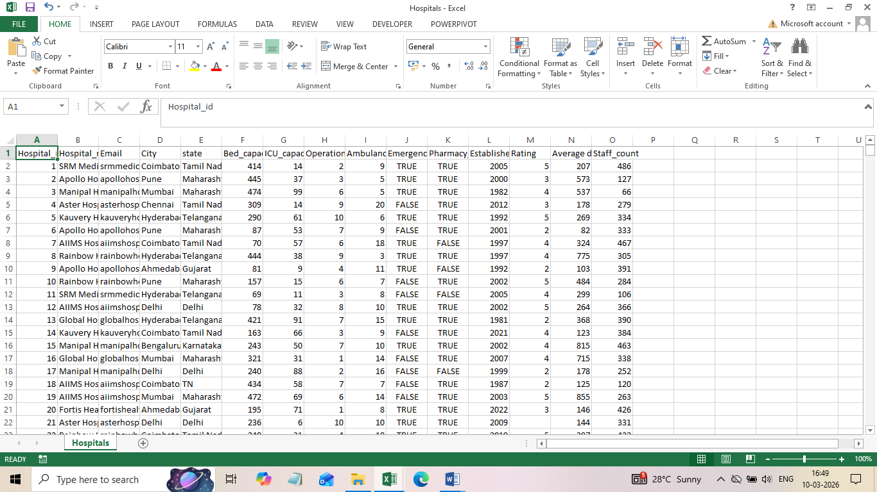
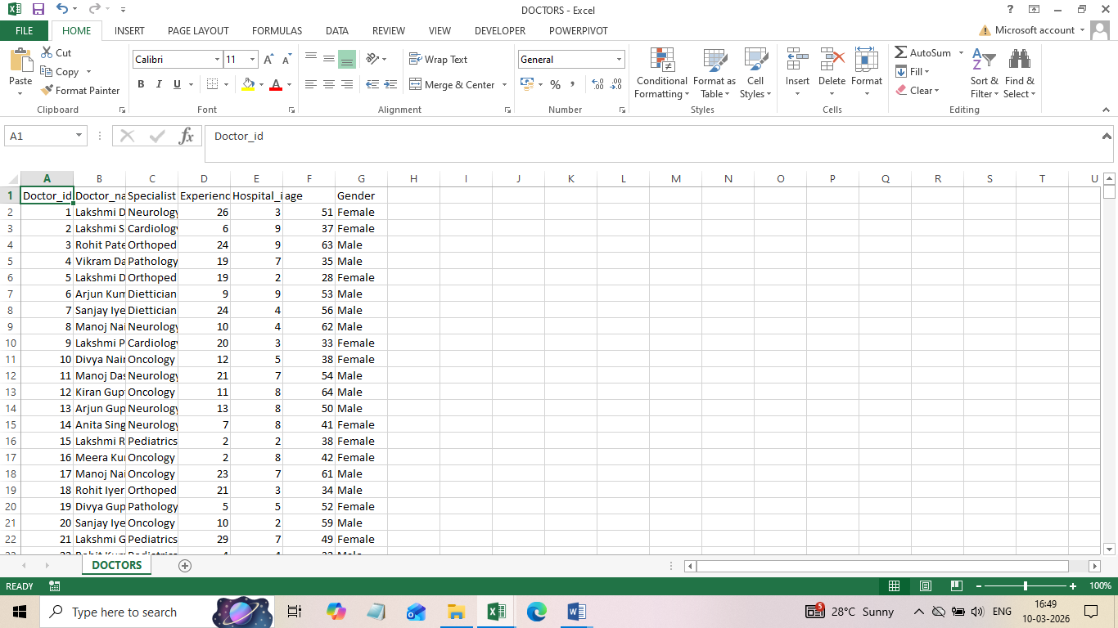
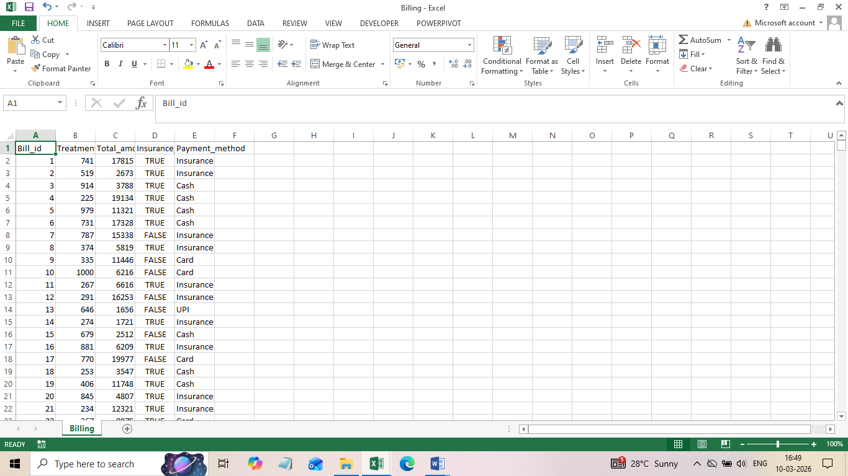

CLEANED DATASET USING SQL QUERIES:
The most common query I done in all sheets was creating raw file that means if any mistakes occur in queries also there is no need to import data from begin.
PATIENTS:
a. UPDATE patients
SET Gender='Male'
where Gender='M';
This query is used to update the gender column with respect to the specific data consistency.
b. UPDATE patients
SET city = CASE city
WHEN 'CBE' THEN 'Coimbatore'
WHEN 'tricy' THEN 'Trichy'
WHEN 'Tricy' THEN 'Trichy'
WHEN 'Mysuru' THEN 'Mysore'
END
WHERE city IN ('CBE', 'tricy', 'Tricy', 'Mysuru'); This case query is also used to update the data with respect to their consistency.
. select patient_id, count(patient_id) from patients
group by patient_id
having count(patient_id) >1;
This query is used to display the duplicates which will be helpful to ensure whether the duplicates removed or not.
d. CREATE TABLE patients_clean AS
SELECT DISTINCT * FROM patients;
The distinct is used to remove duplicates.

HOSPITALS:
- UPDATE hospitals
set STATE=case STATE
when 'TN' then 'Tamil Nadu'
WHEN 'WB' then 'West Bengal'
end
WHERE STATE IN ('TN','WB');
This case query is also used to update the data with respect to their consistency.

DOCTORS:
- SELECT *
FROM doctors
WHERE Experience_years > age - 22;
This query is based on the assumption that doctors generally begin their medical careers at approximately 22 years of age after completing their basic medical education. Therefore, the maximum possible years of experience for a doctor can be estimated by subtracting 22 from their current age.
- SELECT *,
CASE
WHEN Experience_years < 5 THEN 'Junior'
WHEN Experience_years BETWEEN 5 AND 15 THEN 'Mid-Level'
ELSE 'Senior'
END AS experience_level
FROM doctors;
This query uses a case statement to classify doctors based on their experience level.
- Junior – Less than 5 years of experience
- Mid-Level – Between 5 and 15 years of experience
- Senior – More than 15 years of experience.

APPOINTMENTS:
UPDATE appointment
SET payment_method =
CASE
WHEN consultation_fee < 300 THEN 'Cash'
WHEN consultation_fee BETWEEN 300 AND 500 THEN 'Card'
ELSE 'UPI'
END;
This query helps to simulate different payment modes based on fee ranges, which can support financial analysis and payment behavior insights in healthcare data.
TREATMENTS:
- SELECT *,
(Medicine_cost + Lab_cost + Procedure_cost) AS total_cost
FROM treatments;
This query retrieves all records from the treatments table and calculates the total treatment cost for each patient. Calculating the total treatment cost helps in analyzing overall patient expenditure, which is useful for financial analysis and healthcare cost management.

BILLING:
- SELECT*,
CASE
WHEN Total_Amount < 2000 THEN 'Low Bill'
WHEN Total_Amount BETWEEN 2000 AND 8000 THEN 'Medium Bill'
ELSE 'High Bill'
END AS Bill_Category
FROM billing;
This query helps in segmenting billing data into different cost levels, making it easier to analyze patient billing patterns. It can also support hospitals in identifying low-cost, moderate-cost and high-cost treatments, which is useful for financial analysis, reporting, and decision-making.

DASHBOARD CREATION:
The KPI’s displayed in the dashboard are as follows:
- Total Patients
- Total Hospitals
- Total Doctors
- Total Appointments
- Doctor Workload
- Hospital Utilization.

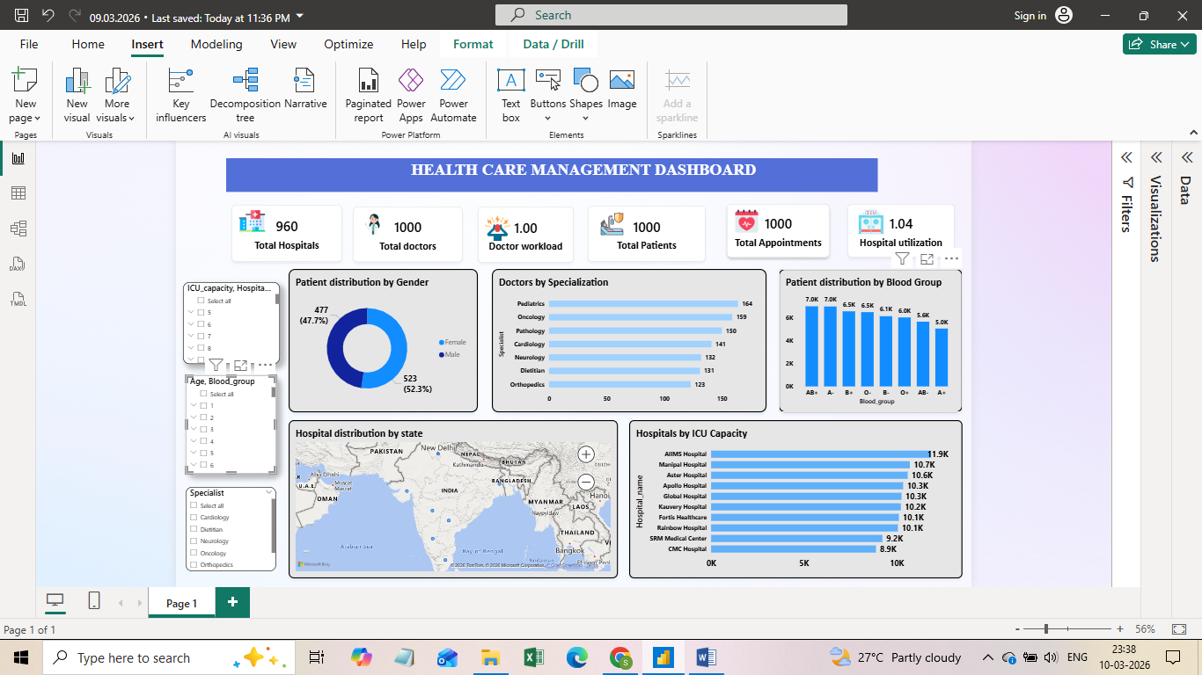

CLINICAL INSIGHTS:

Female patients are high in proportion compared with male patients.

Certain blood groups appears more frequently among patients.

Some medical specializations have more doctors which may indicate uneven resource distribution.

Hospital utilization is slightly above optimal capacity, suggesting high patient demand.

ICU capacity varies significantly across hospitals, which may impact critical patient care.

Patient demographics data helps identify healthcare demand patterns across different groups.

ACTIONS:

Hospitals should strengthen women-focused healthcare services such as gynecology clinics, maternity care and preventive screening programs.

Hospitals should maintain blood bank inventory for the emergency readiness.

Hospitals should balance doctor work allocation across departments to improve patient care and reduce workload pressure.

Healthcare administrators should expand hospital infrastructure, increase bed capacity and optimize patient scheduling.

Hospitals with lower ICU capacity should invest in expanding intensive care facilities and emergency care resources.

Hospitals should design targeted healthcare programs and preventive health initiatives based on demographic trends.

CONCLUSION:

This Healthcare management Dashboard provides valuable insights into patient demographics, hospital capacity and doctor specialization. By using interactive visualizations, decision-makers can improve resource allocation and optimize healthcare services. Overall, this project demonstrates how data analytics support better clinical insights.

